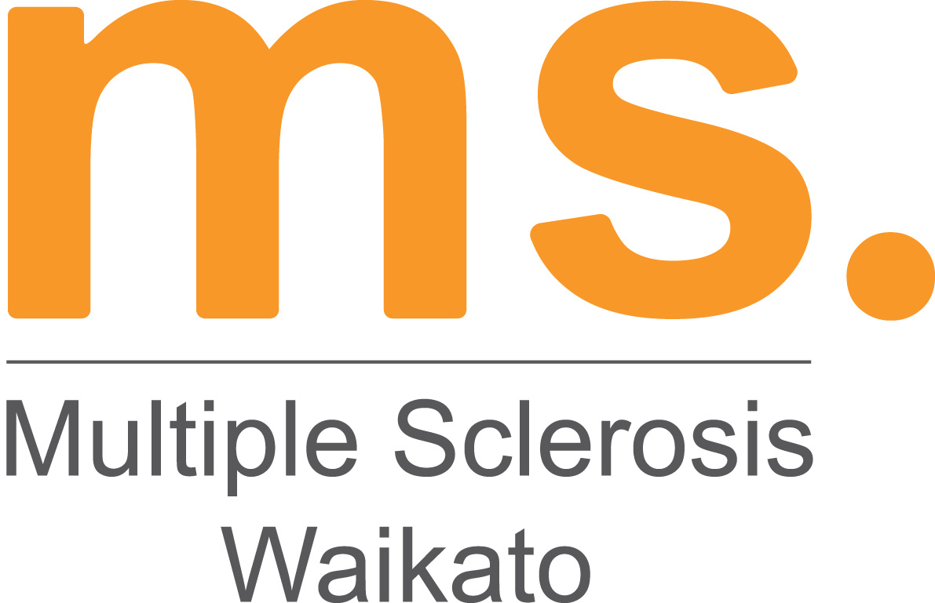

The Michael Ford Memorial Charity Golf Tournament – Friday 14th March, Ngahinepouri Golf Club

Michael Ford was a successful, dynamic businessman. Running his own insurance company and happily married with two children, the world was his oyster. Michael was a keen sportsman actively involved and with a lifelong passion for horseracing and rugby, he had played squash for many years and recently taken up golf.

Michael and his family’s world was turned upside down when at the age of 36 he was diagnosed with Multiple Sclerosis. Sadly, Michael has since passed away.

Multiple Sclerosis is one of the most common diseases of the central nervous system; it causes disruption to nerves, which conduct electrical impulses to and from the brain. Affecting 1 in every 1000, women are 3 times more likely to be diagnosed with MS with the average age of diagnosis being mid 30’s. Symptoms include fatigue, pain, spasticity, cognitive and visual problems, bladder and bowel issues. The cause of MS is still unknown. For some people MS can be manageable and they live fairly full lives, for others like Michael there is a deterioration over time, which eventuates to full time care.

Michael established this tournament over twenty years ago; we have continued to organise this as an annual event and it is taking place on Friday 14th March at Ngahinepouri Golf Club.

On behalf of MS Waikato, I would like to invite you to participate in this and support MS Waikato.

Registrations are now being taken. Entry is $50, entries to be received in full. The event includes morning tea, a sausage sizzle and soft drink on the course. Morning tea and registrations will be from 10.00am with a shotgun start at 11.00am. This is a Stableford tournament with great prizes for men, ladies and non- registered golfers. Entry can be made as a team but this is not a team event.

A registration form is attached, this form and any enquiries can be sent to Janet Buckingham - janet@mswaikato.org.nz , phone 07 834 4740 or mail to MS Waikato, PO Box 146, Hamilton.

MS Waikato is a small not for profit organisation, we are not government funded and provide support services to clients, and their families/whanau affected by Multiple Sclerosis and Huntington’s Disease.

The Tournament is one of our major fundraisers and all funds raised will remain in the Waikato to assist with the provision of support, education and information services for our clients and their families.

If you would like to receive information on sponsoring the event, please contact Janet Buckingham. We have a range of sponsorship options to suit different organisations and individuals, gold and platinum sponsorship includes a complimentary team entry to the tournament. MS Waikato is a registered Charitable Trust, all donations are tax deductible. We hope you will be able to join us for the day.

Our Sponsors of the 2024 Michael Ford Memorial Charity Golf Tournament were:

Gold Sponsors
Platinum Sponsors
Midland Neurology
New World - Te Rapa
Stihl Shop - Te Rapa

Gold Sponsors
Ngahinepouri Golf Club
Craigs Investment Partners Ltd
Stainless Design Ltd
Move My Pension
Keppler
Nigel Tate Financial Planning
Modern Construction
Laser Plumbing Hamilton West
Brian Perry Charitable Trust
Hamilton Workingmen’s Club
Dulux
Tree Menders Ltd

Silver Sponsors
Waitomo
Your Way – Kia Roha
South City Pharmacy

Bronze Sponsors
The Brand Makers
HR Connect
Gallagher Insurance
Hoyts Te Awa
Print House Ltd
Te Aroha Mineral Spas
Flagstaff Pharmacy
Vilagrad Winery
Bunnings Warehouse - Te Rapa
Davy Engravers
OneStaff
Pro Drive Golf
Fletcher Steel

